UXP-HTML5-L2-0002: Search Table List

Level: L2

Technologies: HTML5, Css3, Bootstrap**.**

Case Study: To Create Search Table List

**Tips to start**

**Case Study – HTML Search table list**

Visual:

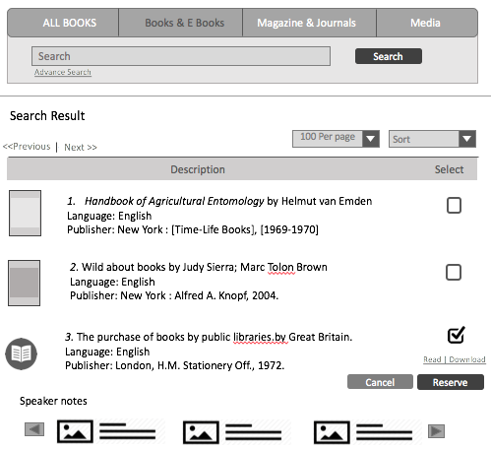

**Getting Started:**

Bootstrap your HTML page, create a HTML5 page with CSS3.

**Dependencies:**

develop html page using bootstrap framework. Refer the links below.

Bootstrap: <http://getbootstrap.com/>

**Additional notes:**

* Create a table in HTML5.
* Create a navbar with search box as shown in the visual.
* <table><tr><td> should not be used.
* Pagination and dropdown should be included.
* Page should be responsive in all devices (desktop, mobile & tab)
* Test devices responsiveness using Chrome browser